User Manual

OEM reader ISO14443 A/B + ISO 15693
(version 1.1)

*All rights reserved
**May be changed without noticed

A. OVERVIEW

The OEM reader is a Mifare® ISO14443 A,B and ISO15693 read/write device with a typical
operating distance of 50-100mm . The reading range of the module is depending on the antenna and
tag. Also printed circuit board antennas are supported.

The OEM reader combines all basic functions to access the ISO14443A,B and ISO15693 Card. Including Mifare® Smart Card, Mifare PRO etc. Its versatility allows a flexible and efficient application in different configurations and system devices. Because of the small size the module can be integrated easily into existing data collection applications such as portable terminals, ticketing, machines vending or access control.

The 13.56MHz OEM reader is a very compact device designed for fast integration into portable or stationary readers.

The OEM reader was designed for simple integration. The serial TTL-interface can be directly connected to microprocessors and easily converted to the RS232/RS485/RS422 serial interface device.The protocol can be tested using any terminal.

B. DEVELOPMENT KIT AND APPLICATION SOFTWARE

Purpose
The Development Kit allows developers to evaluate contactless technology and enables easy applications development for WINDOWS 98, 2000 and XP.Developers will be able to get acquainted with the products compliant with different standards（ISO14443A,ISO14443B,ISO15693）

Audience
The Development Kit it has been designed to suit all of the PC developers’ community ranging from
beginners to experts, who will benefit from this user friendly evaluation software, and API permitting the development of application with the most common tools.

Typical Applications
Many applications can be developed with the Development Kit such as PC logon, Internet/intranet
access, e-commerce, point of sale, identity confirmation; Access control, Offline Ticketing,
Customizing cards, Road pricing etc. in all everywhere a PC or Microprocessor needs to
communicate with a contactless transponder.

C. SPECIFICATION

Type OEM reader 13,56MHz
Operating frequency 13.56MHz
Power consumption 100mA
Supply voltage 5VDC
Operating temperature -10℃ ~ +80℃
Tags supported ISO14443A, ISO14443B , ISO15693 Tags
Interface CMOS –TTL / RS232
Transmission speed 9600,n,8,1 up to 115200 Baud
Signals Power LED, Reading red and green LED (TTL output),
Beep(TTL output)
Number of Pins 10
Operating distance Up to 100mm, depending on card and antenna
Dimensions 39mm×19mm×10mm External Antenna

D. CONNECTION PLAN

Pin function OEM880
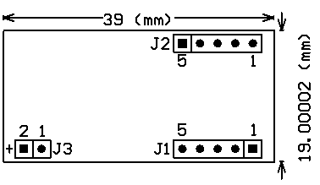

Connector J1:

PIN 1 ---- LEDG
PIN 2 ---- +5V (DC)

PIN 3 ---- GND

PIN 4 ---- LED

PIN 5 ---- Buzzer

Connector J2:

PIN 1 ---- RESET

PIN 2 ---- RXD
PIN 3 ---- TXD
PIN 4 ---- GND
PIN 5 ---- +5V (DC)

Connector J3:

PIN 1 ---- ANTENNA –

PIN 2 ---- ANTENNA +

Pin function OEM821
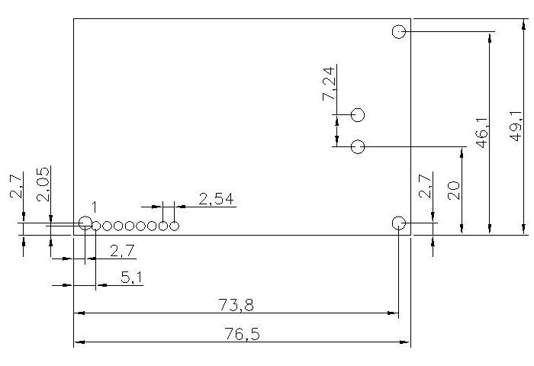

Connector:

PIN 1 ---- Data TX OUT (RS422)

PIN 2 ---- Data RX IN (RS422)

PIN 3 ---- Data TX OUT (RS232/RS422)

PIN 4 ---- Data RX IN (RS232/RS422)
PIN 5 ---- GND
PIN 6 ---- +5V (DC)
PIN 7 ---- LED
PIN 8 ---- Buzzer

E. ORDER SPECIFICATION

R-OEM-821-A-232 (Standard reader, 14443A, RS232 interface)
R-OEM-821-A-485 (Standard reader, 14443A, RS485 interface)
R-OEM-821-MT-232 (Standard reader, 14443A,14443B, ISO15693, RS232 interface)
R-OEM-821-MT-485 (Standard reader, 14443A,14443B, ISO15693, RS485 interface)
R-OEM-880-A-232 (Small reader with separate antenna, 14443A, RS232 interface)
R-OEM-880-A-485 (Small reader with separate antenna, 14443A, RS485 interface)
R-OEM-880-MT-232 (Small reader with separate antenna, 14443A,14443B, ISO15693, RS232)
R-OEM-880-MT-485 (Small reader with separate antenna, 14443A,14443B, ISO15693, RS485)

F. SUPPLIER

iDTRONIC GmbH
Donnersbergweg 1
67059 Ludwigshafen
Germany
www.idtronic.de

